Meshaal Mouawad
Mississippi State University, Electrical and Computer Engineering Department,
This is a summary report of my research assignments I was given by my advisor during my PhD program
Summary Report: week 12
For Research Assignments of my PhD
Summary:

- TSP Algorithms
Assignment: | - TSP (Travelling salesman problem)
Completed: | Yes
Submitted:
Problems: | NA
Explain: | NA
Procedure: | I used another Python code for TSP and successfully run it! Gorubi Module was used for optimization. The output for the optimal path is:  [(0, 1), (1, 2), (2, 3), (3, 4), (4, 5), (5, 0)]  Time taken by MTZ formulation = 1.2135167121887207  The solution visualization is:

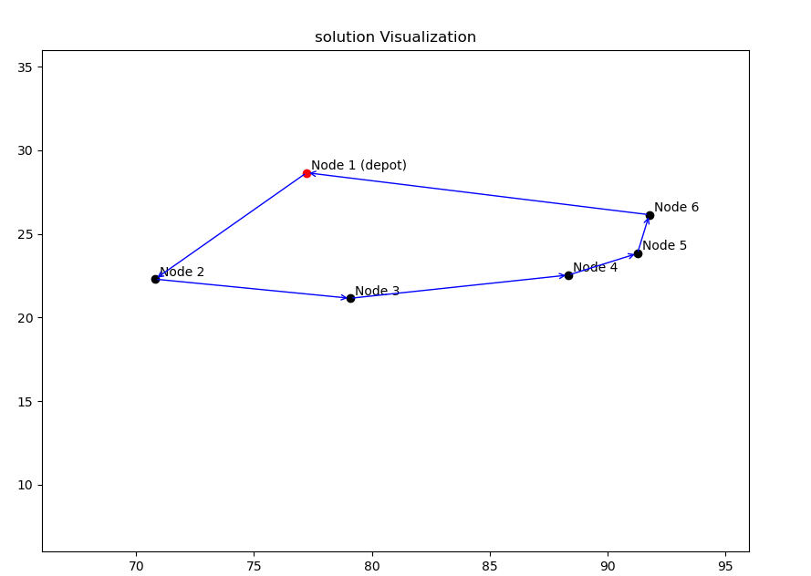

Appendix

This Report was submitted in 2019 for Mississippi State University, Electrical and Computer Engineering Department during Fall 2019 foe the course of Introduction to Radars Engineering instructed by Dr. Ball John Meshaal Mouawad, Mississippi State University, Starkville, MS 39759 USA (e-mail: mm4922@msstate.edu).

